Changes in the existing software <https://app.gdprcomplet.ro/survey/Login>

There are 3 changes that we require:

* Backend changes
* Front end changes
* UI translations (just front end)

# Backend changes

1. User creation – the only information that we want to store is:
   1. Name
   2. Email
   3. Company name
   4. Account type
   5. Enabled
   6. Password
   7. Instead of Birthday – use Expiration Date – that is today + 1 year (if I create the user today 14.06.2019 – the expiration date will be 14.06.2020).
   8. The other fields must be hidden and excluded from user list
   9. 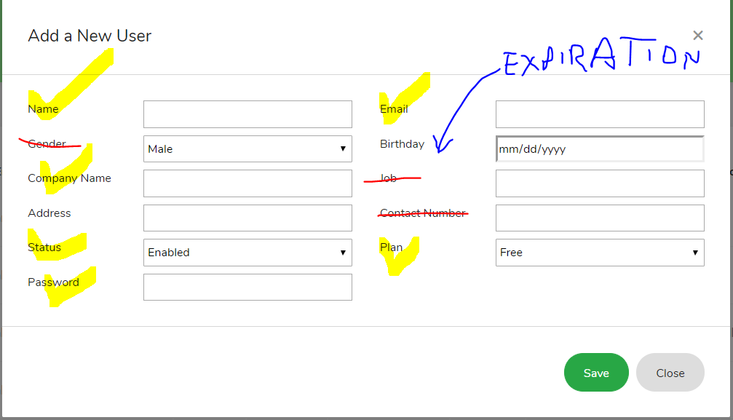
2. Modify <https://app.gdprcomplet.ro/survey/user/customers> to match the changes that we ask in the customers table and drop all existing customers – we want a clean table now.
3. Please double check the file upload module <https://app.gdprcomplet.ro/survey/document/uploads> because it does not allow me to upload docx files – after a refresh the file is missing. 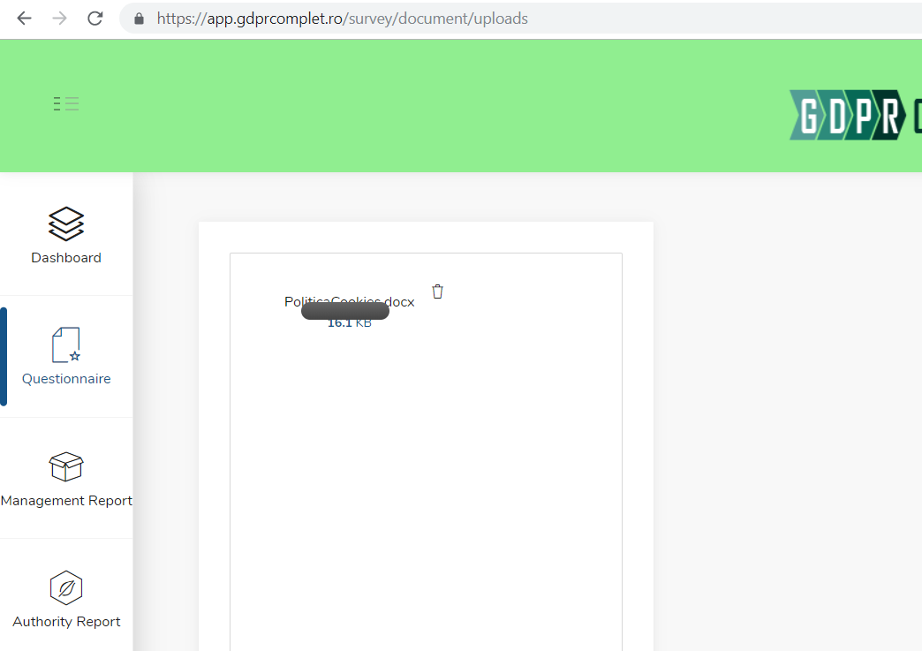
4. After you fix this part – please write a short information regarding how to upload and than link a file from the survey management.

# Front end changes

1. Create account as well from <https://app.gdprcomplet.ro/survey/Login> . Put a link near Forget password? That will say Create account that will take a user to a sign up page that requires:
   1. Name
   2. Email
   3. Company name
   4. Password
   5. When the user creates this account it will be enabled, valid for 1 year and the Plan will be FREE
2. All the exports must include the following information (on top of every page if possible)
   1. Report generated by (customers name) on behalf od (company name)

# Translate the UI

Please note that for this part – we will do a revision after you change the texts below:

<https://app.gdprcomplet.ro/survey/Login>

MAGIC IS IN THE DETAILS

Please use your credentials to login.   
If you are not a member, please [register](https://app.gdprcomplet.ro/survey/register).

AUDIT SI CONFORMARE GDPR

Utilizați-vă datele de conectare pentru a vă conecta.

Dacă nu sunteți membru si doriti un cont, vă rugăm să ne contactati contact@gdprcomplet.ro

Login

E-mail

Parola

Ai uitat parola, click aici?

<https://app.gdprcomplet.ro/survey/questions/getSurveyResult>

Welcome Message

Lorem Ipsum is not simply random text. It has roots in a piece of classical Latin literature from 45 BC, making it over 2000 years old.

Bine ai venit

Aici gasesti progresul tau in conformarea GDPR. Poti oricand sa actualizaezi datele prin completarea chestionarului (link).

Overall Progress 🡪 Progress General

GDPR Compliance 🡪 Conformare GDPR

Last Updated 09.05.2019 🡪 Ultima Acualizare

Page Progress 🡪 Progress pe Capitole

You do not apply on 🡪 Intrebari care nu ti se aplica

You do not comply on 🡪 Intrebari la care nu esti conform

You comply on 🡪 Itrebari la care esti conform

Questions 🡪 Intrebari

Graph

Comply 🡪 Conformare

Do not comply 🡪 Neconformare

Do not apply 🡪Nu se aplica

Progress By Page 🡪 Progress pe Capitole

Todo List 🡪 Ce mai este de facut?

Double Check 🡪 Aspecte de re-evauat

Button Check 🡪 Verifica

++++++++++++++++++++++++++++++++++++++++

Menu:

* Dashboard 🡪 Sumar
* Questionare 🡪 Chestionar
  + Survey 🡪 Intrebari
  + To do 🡪 Ce mai este de facut?
  + Double Check 🡪 Aspecte de re-evauat
* Management Report 🡪 Raport catre Management
* Authority Report 🡪 Raport catre autorite (ANSPCP)
* User 🡪 Utilizator
  + Account 🡪 Cont
* Help & Support 🡪 Suport
  + Gdpr Compliance 🡪 Conformare GDPR
  + How to use 🡪 Cum sa se foloseste produsul?
  + Tech Support 🡪 Suport Tehnic
  + DPO Conumity 🡪 Comunitatea DPO

<https://app.gdprcomplet.ro/survey/questions/survey>

External navigation: Page 1 of 11. Next

Parcurgeti caplitolele. Capitolul 1 of 11. Next

**** De monifidicat in chestionar Sectiunea xxxxx in Capitolul xxxxxx (Cerasela)

Save – Salveaza

Next - Urmatorul

Previous – Precedentul

<https://app.gdprcomplet.ro/survey/questions/todoList>

TO Do List

Ce mai este de facut?

<https://app.gdprcomplet.ro/survey/questions/doubleCheck>

Double Check 🡪 Aspecte de re-evauat

<https://app.gdprcomplet.ro/survey/document/manageReport>

Welcome Message

Lorem Ipsum is not simply random text. It has roots in a piece of classical Latin literature from 45 BC, making it over 2000 years old.

Raport catre management

Acest raport arata progresul conformarii GDPR pe fiecare capitol in parte si aspectele care mai trebuiesc rezolvate.

Overall Progress 🡪 Progress General

GDPR Compliance 🡪 Conformare GDPR

Page Progress 🡪 Progress pe Capitole

Solve button 🡪 Rezolva

Export button 🡪 Printeaza sau Exporta in PDF

<https://app.gdprcomplet.ro/survey/document/authReport>

Welcome Message

Lorem Ipsum is not simply random text. It has roots in a piece of classical Latin literature from 45 BC, making it over 2000 years old.

Raport catre Autoritate Nationala …..

Acest raport arata progresul conformarii GDPR pe fiecare capitol in parte si poate fi prezentat autoritatii in cazul in care aveti un control sau va sunt solicitate informatii cu privire la actiuniile si eforturiile intreprinse in vederea conformarii.

Export button 🡪 Printeaza sau Exporta in PDF

<https://app.gdprcomplet.ro/survey/home>

Your name 🡪 Nume

Email 🡪 email

Company Name 🡪 Nume Companie

Password 🡪 Parola

Verify 🡪 Reintroduceti parola

Registration Date 🡪 Data inregistrarii

Login Count 🡪 Numar de utilizari

* Footer 🡪 copyright GDPR Complet 2018-2019